

User Manual
Employee Separation Module
www.flowhcm.com



Table of Contents
Employee Exit 3
Upload Excel 7
Final Settlement 8
Employee Clearance 11
Exit Interview 13
Employee Separation Approvals 14
Employee Separation Settings 15
General Settings 16
Clearance Template 17
Questionnaire Category 18
Exit Interview Template 19

Employee Exit
- Navigate to Others Tab and click Employee Separation
- You can see the Employee Exit form
- To add Employee Exit, click on Apply for Employee Exit
- Select Employee and Exit type from dropdowns
- Enter the leaving date of employee
- If Clearance is required select YES and then select a required clearance template if exists else select OTHER in template and set an approval hierarchy along with the Questions filled with every level
- If Exit interview is required select YES and then select a required Exit template and select interviewers
- Select an employee for evaluation
- Enter Interview Date, Time and Place
- If required for the employee to be inactive immediately not after Final Settlement select NO in Inactive Employee After FnF else select YES
- There is another option to either restrict User login or not, if required select YES
- Enter a reason for Employee Exit and attach a file if any
- Click on submit button to raise a requisition
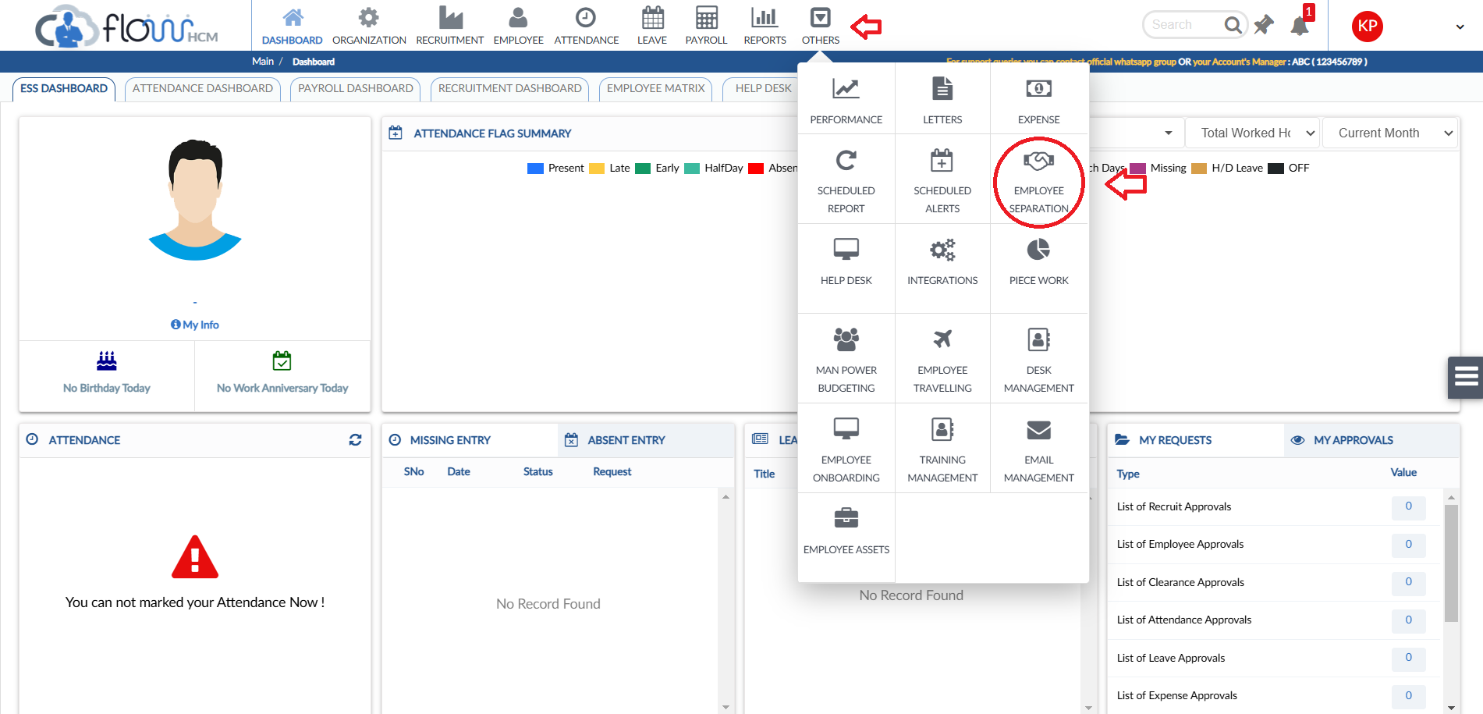
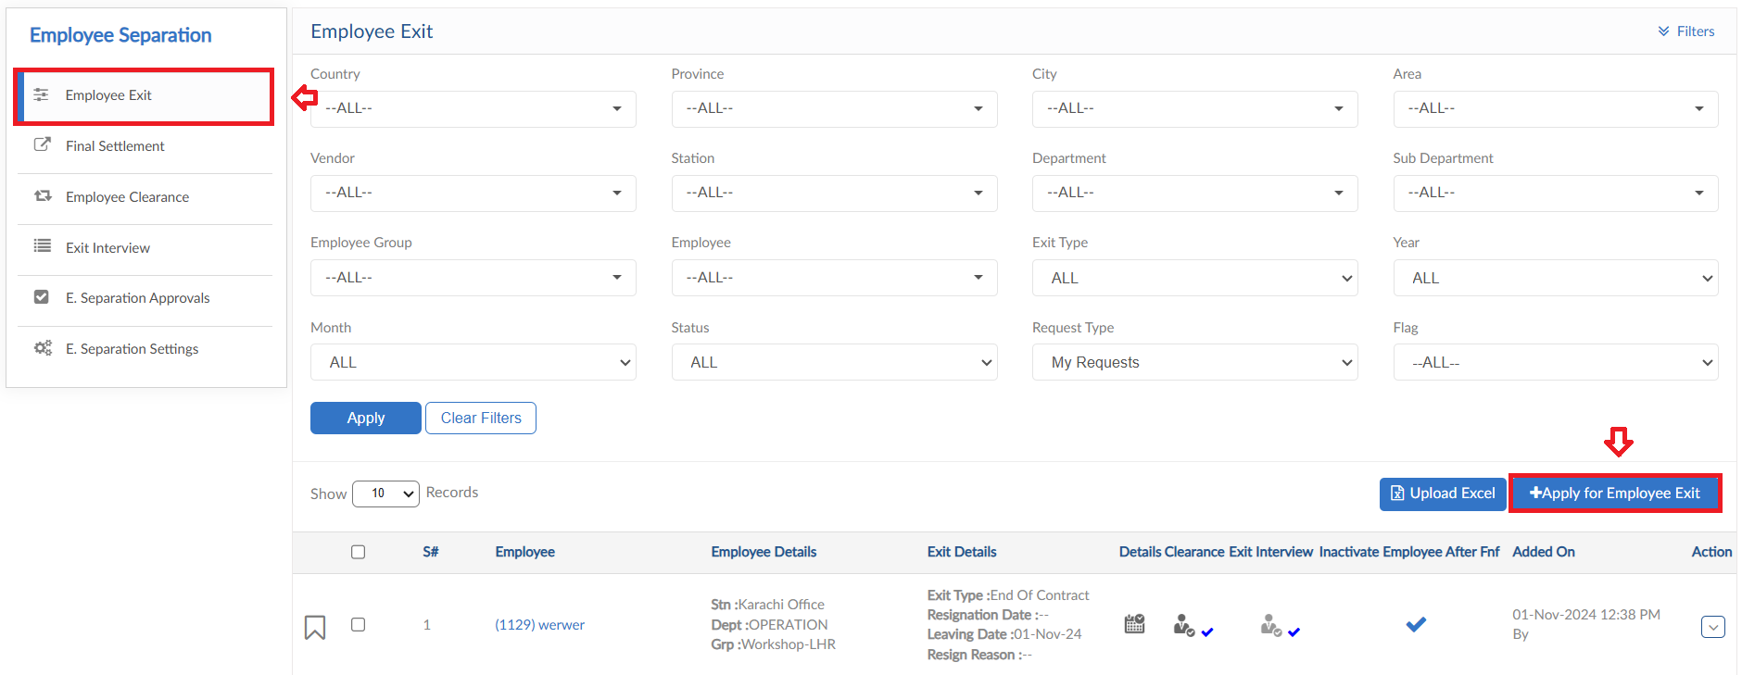
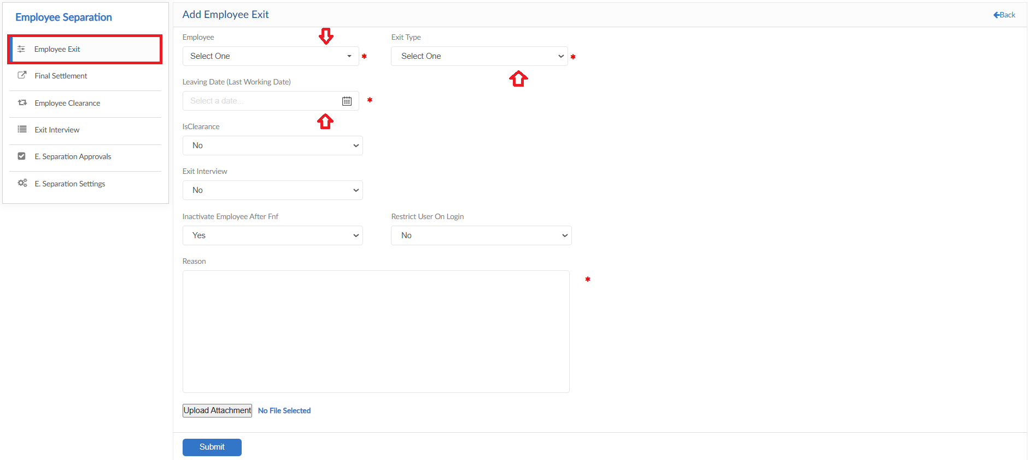
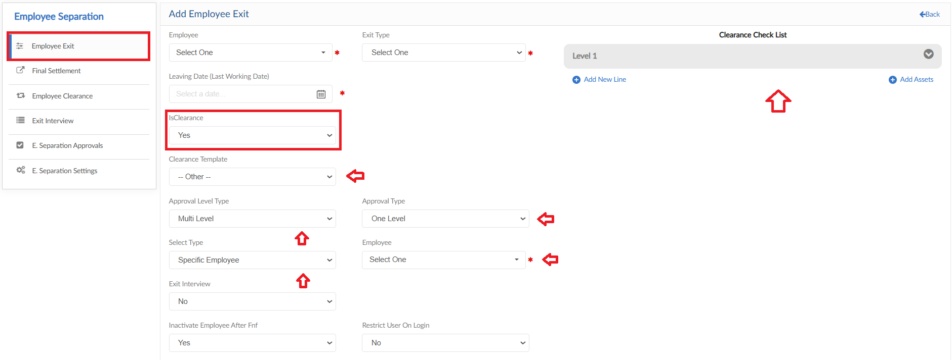
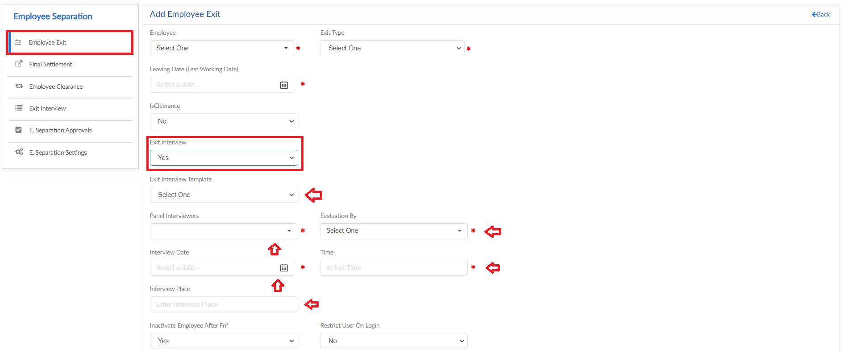
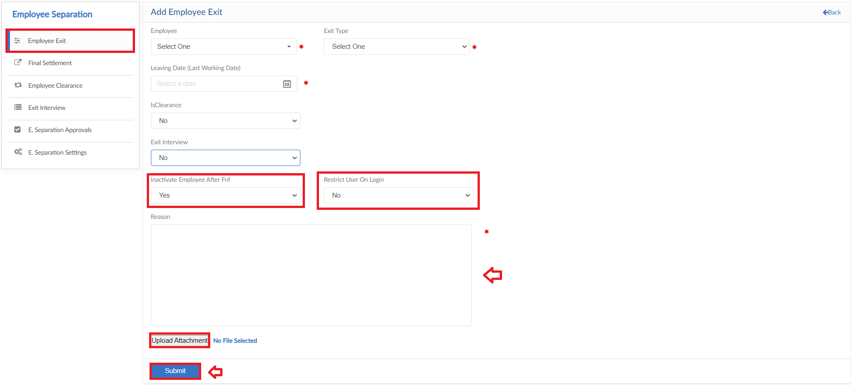

Upload Excel
- If required, upload all Employee Exits in one go user can use upload excel
- Click on Upload Excel button, pop up will be visible
- Then click on Download Sample Template and enter required data
- Click on choose file and then click on Save button to upload all Employee Exits
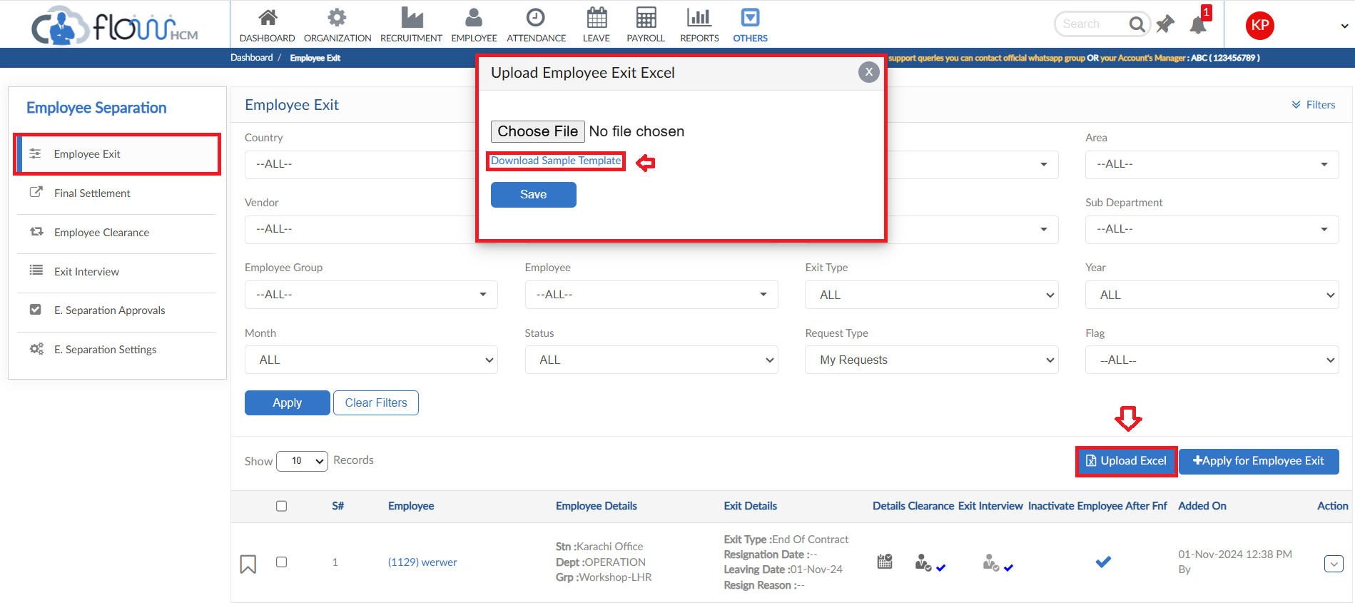
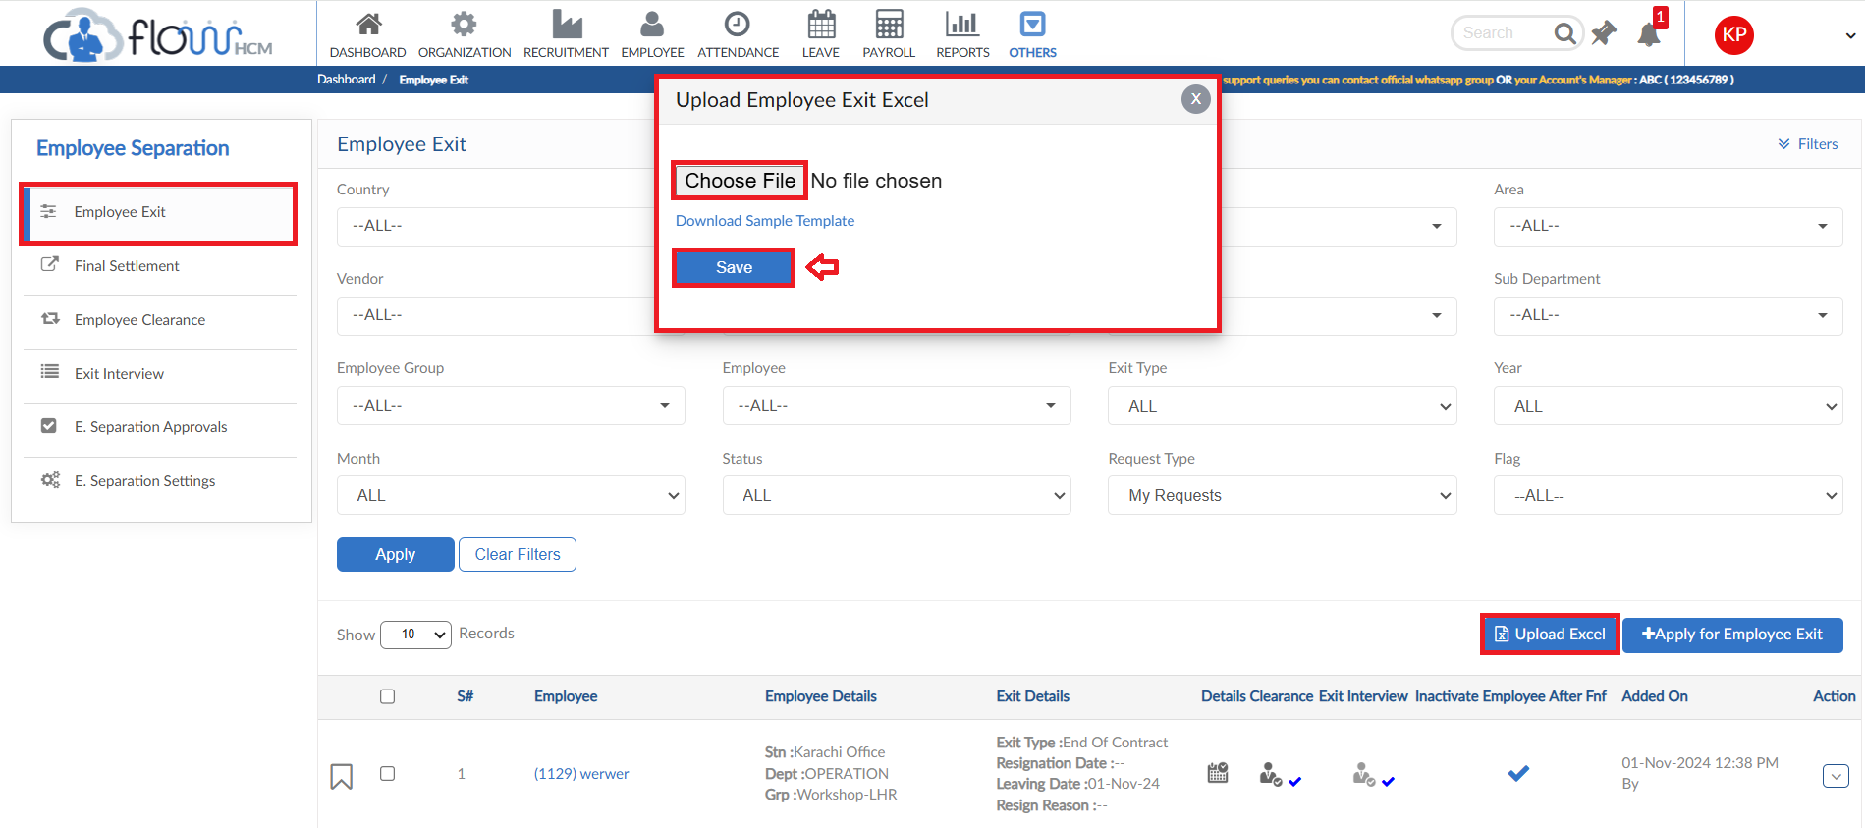

Final Settlement

- Here you can see Final Settlement form
- Click on Run Final settlement button
- Select criteria for Final settlement and then click on preview button
- After clicking on preview, the system will show the FnF details of selected employees
- Click on Save to proceed button after viewing the details
- Final settlement grid will be populated with the entry
- Click on Action button click on Disburse else delete if any changes required
- Disbursing the settlement will show a pop up for confirmation select Yes to continue
- Add Month, Year and Reason in which Final Settlement needs to be disbursed
- Month, Year and Disbursed details will change in grid after saving
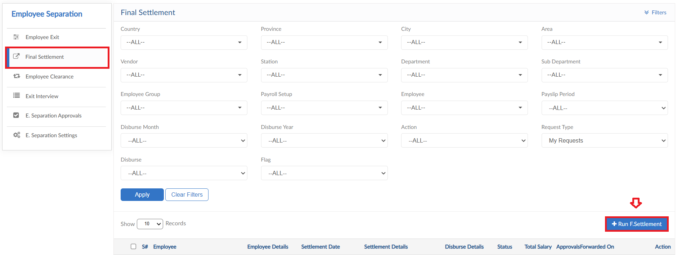
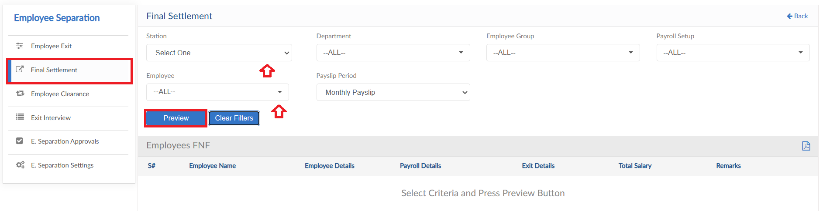
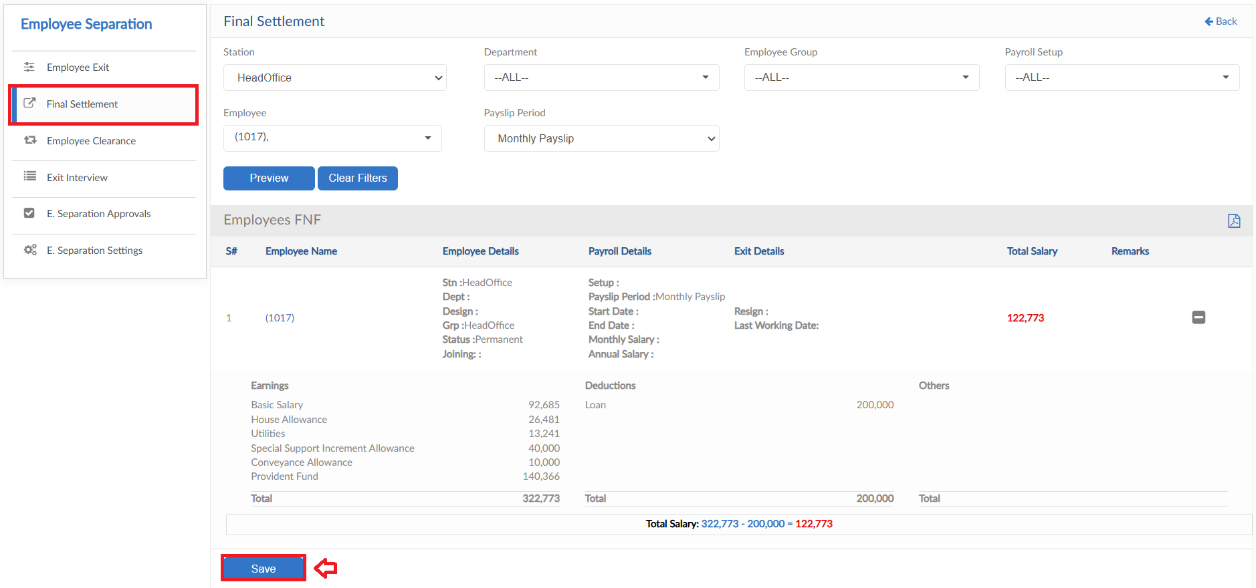
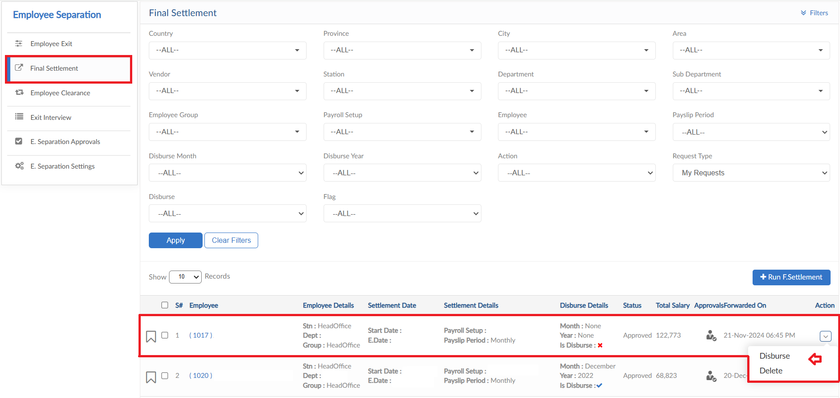
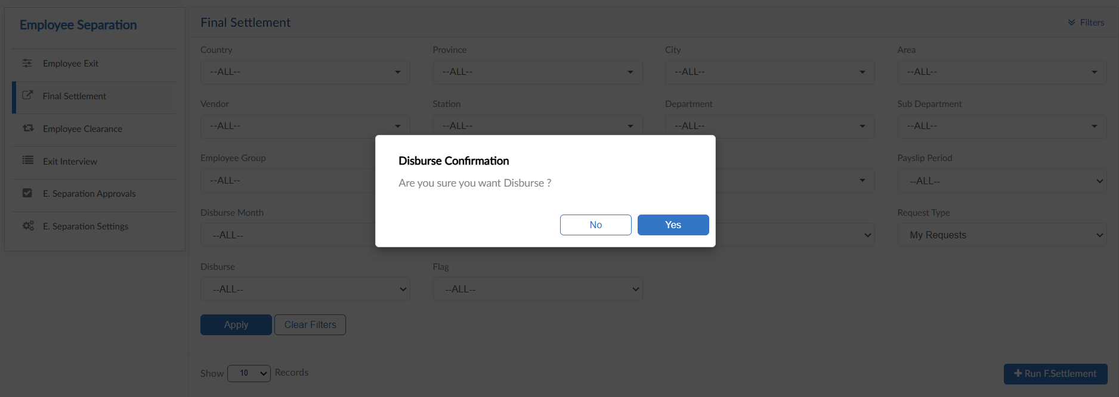
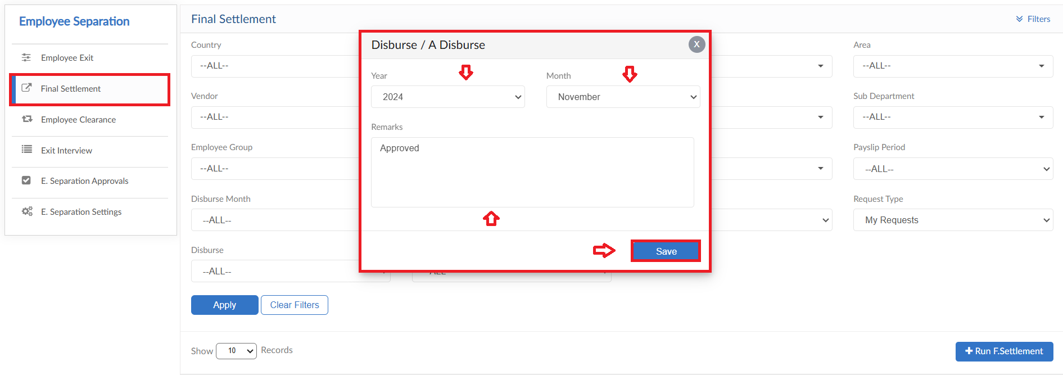
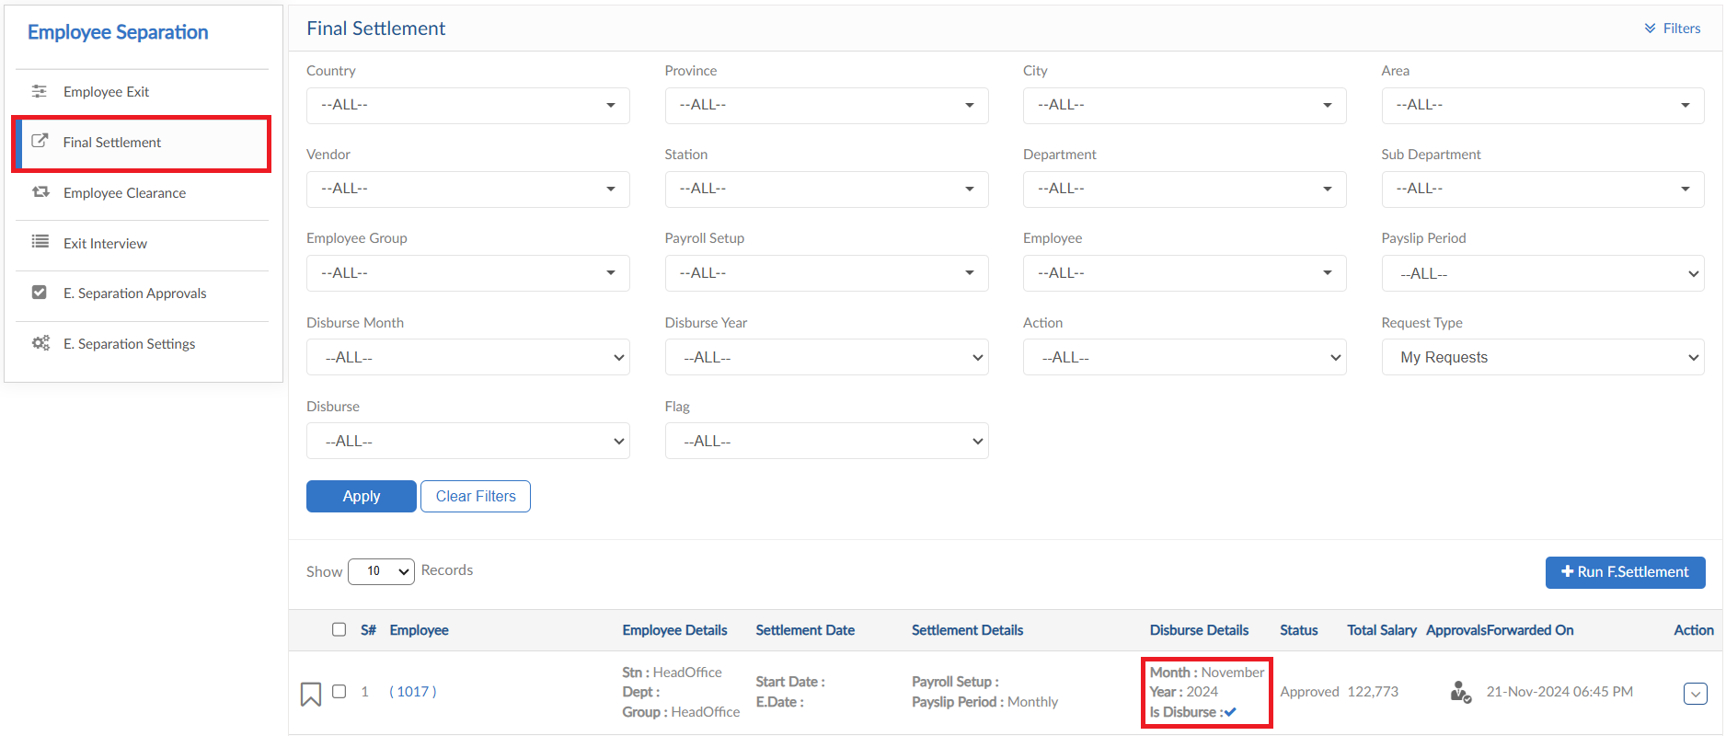

Employee Clearance

- Here you can see Employee Clearance form
- When Employee Exit will be submitted with clearance, the request will fall in Employee Clearance grid
- Can use filter criteria to view required data in grid
- Click on clearance pop up to view the template
- Clearance can be processed by Action button, view and download features are also available
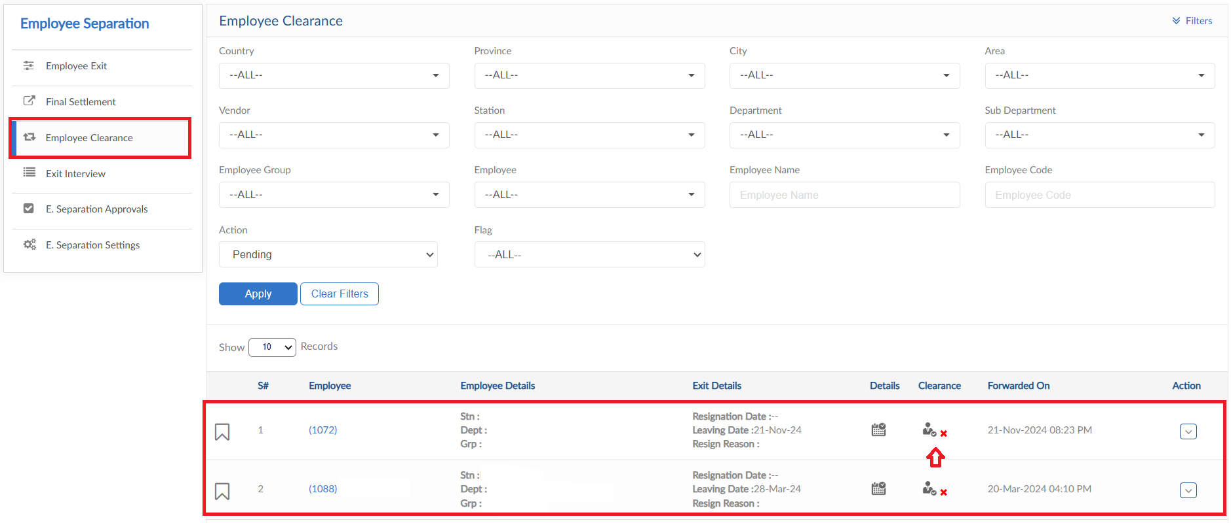
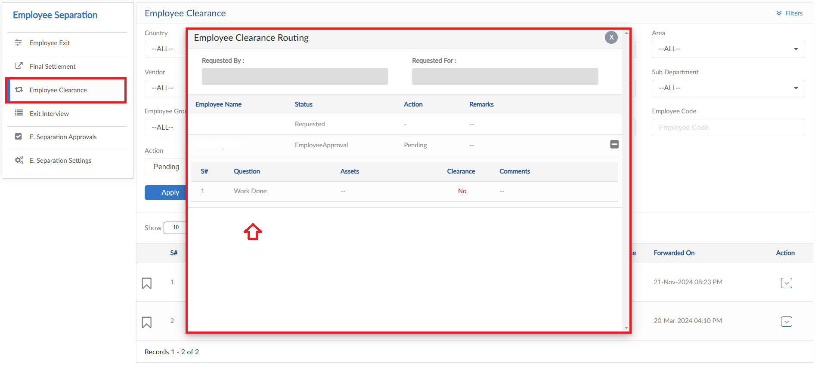
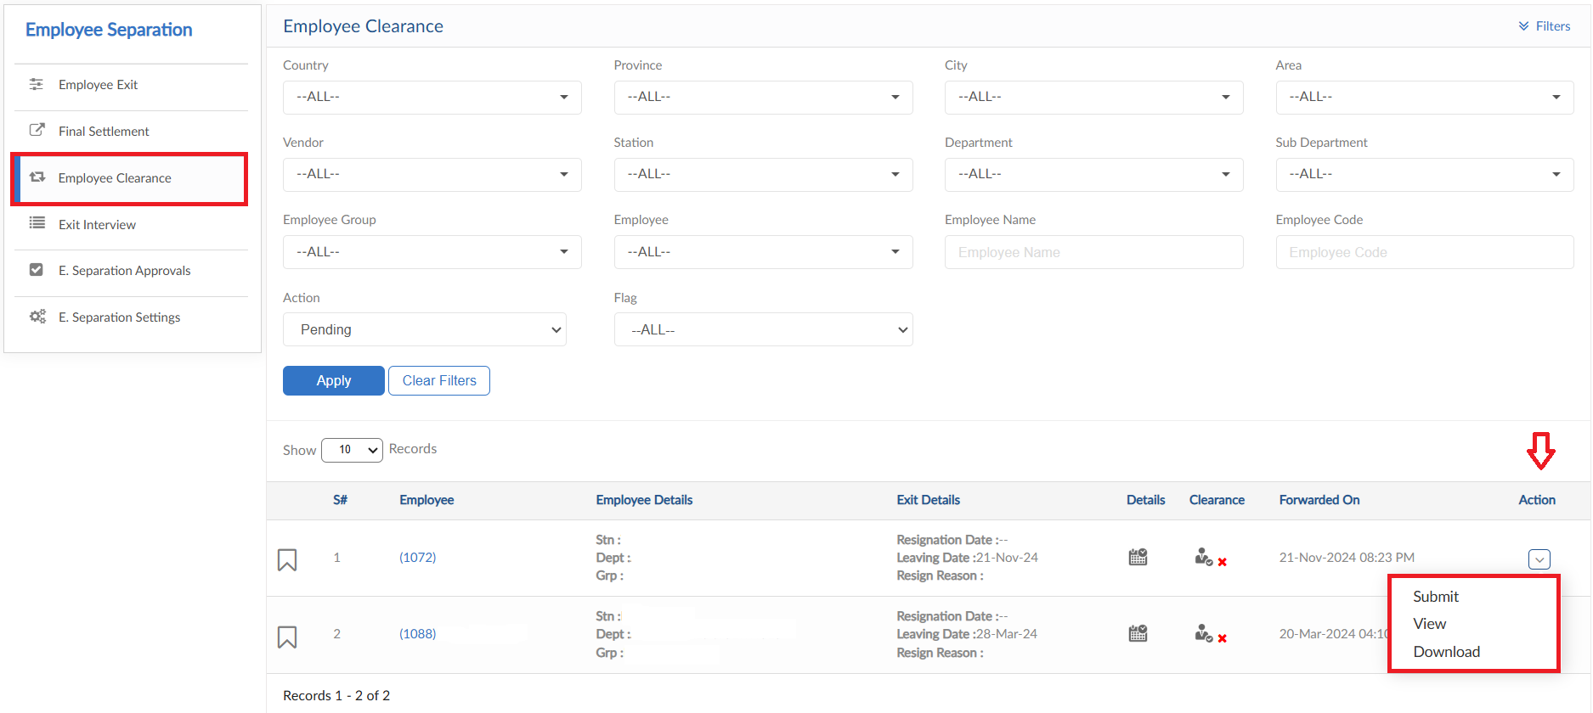

Exit Interview

- Here you can see Exit Interview form
- When Employee Exit will be submitted with exit interview, the request will fall in Exit Interview grid
- Can use filter criteria to view required data in grid
- Click on evaluate button to view the evaluation
- Enter all the comments against the questions
- Then click on submit button
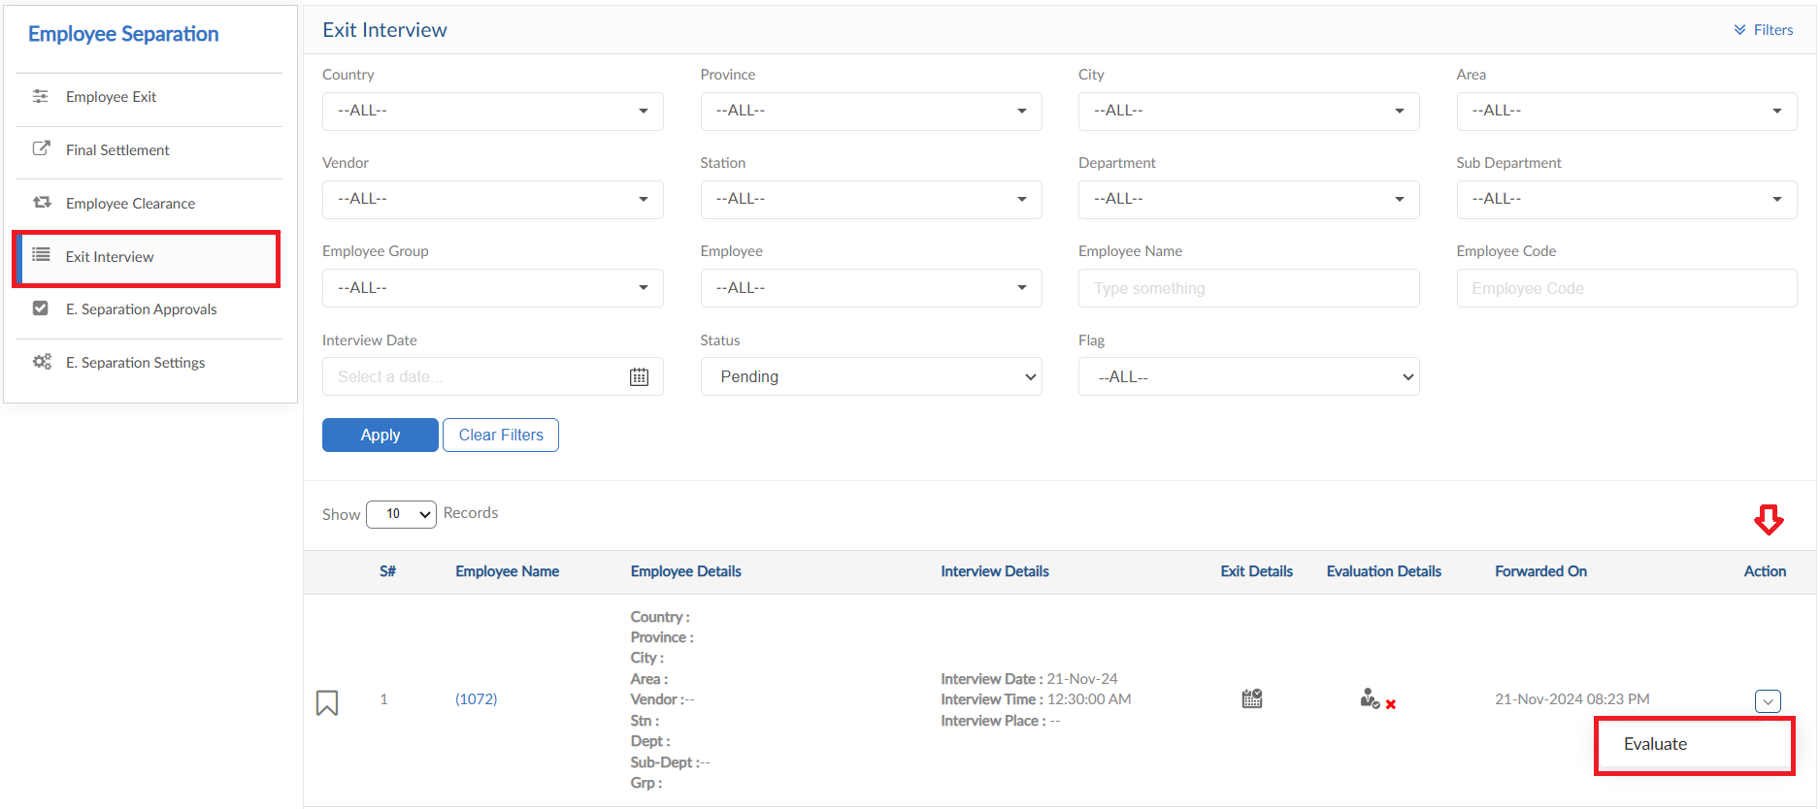
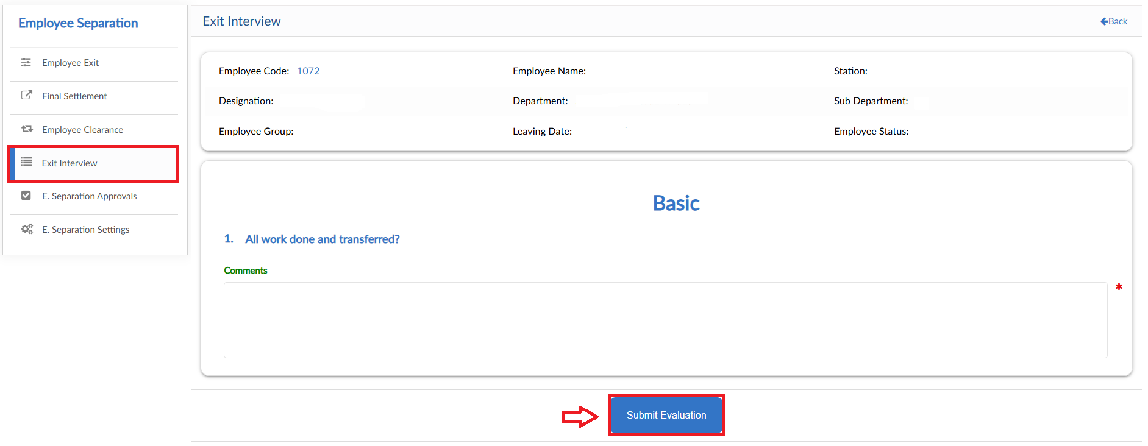

Employee Separation Approvals

- Moving to the next Tab Employee Separation Approvals
- Employee Exit requests that are set on approval hierarchy will fall in this Employee Separation Approvals grid
- Can use filter criteria to view required data in grid
- Click the maximize button to view the details
- Approve or Reject the request from Action button
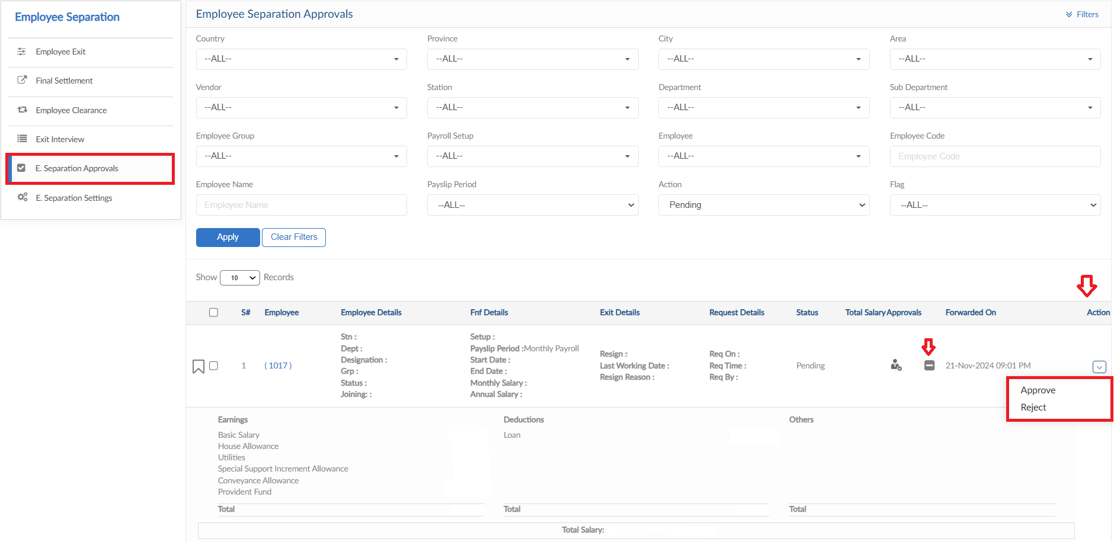

Employee Separation Settings

- Moving to the next Tab Employee Separation Settings, this Tab consists of multiple settings
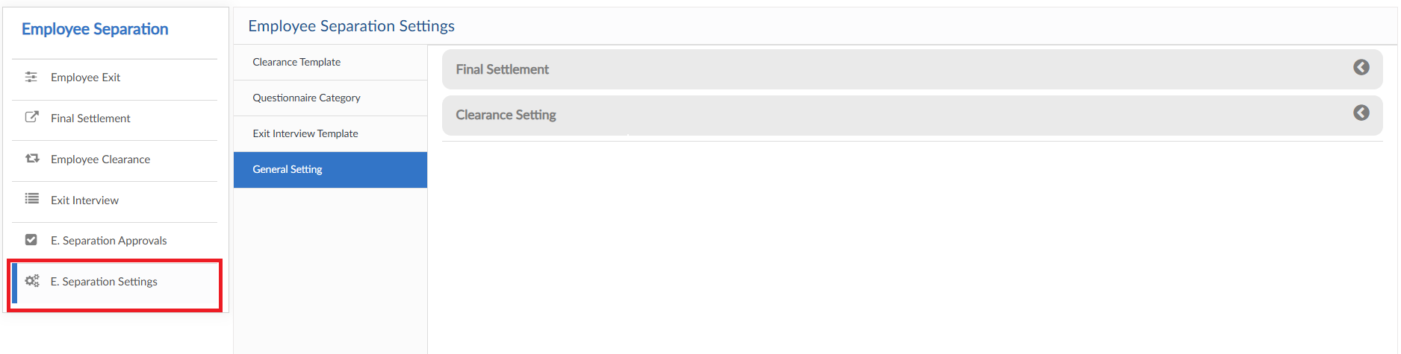

General Settings
- Click on General Settings, Final Settlement and Clearance settings are given
- Final settlement settings allow to set approval hierarchy for FnF request
- Clearance setting has option to send request of clearance to all selected users at once instead of hierarchy (one by one) set in Employee exit request
- After the settings are done click on save button
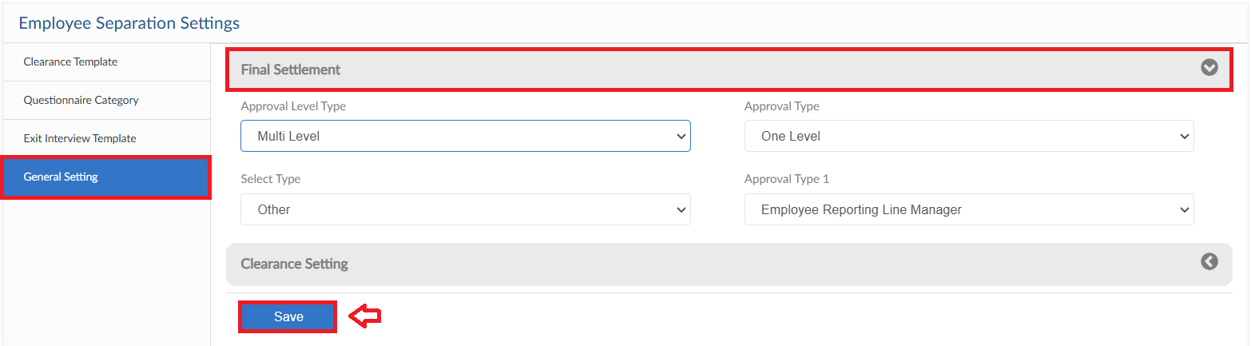
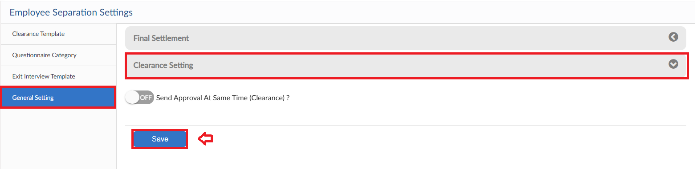

Clearance Template
- Moving to the next Tab Clearance Template in General settings
- In this form templates for clearance can be created beforehand and then just select from dropdown of clearance template in Employee Exit
- Click on Add Clearance Template to create templates
- Enter clearance details and then click on submit button to save the template and then just select the template from dropdown in Employee Exit

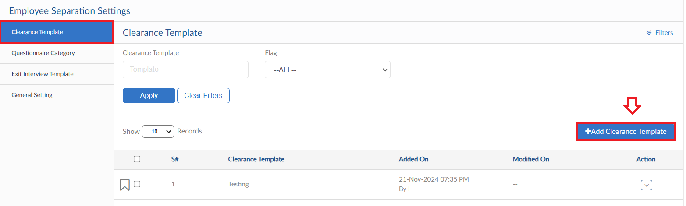
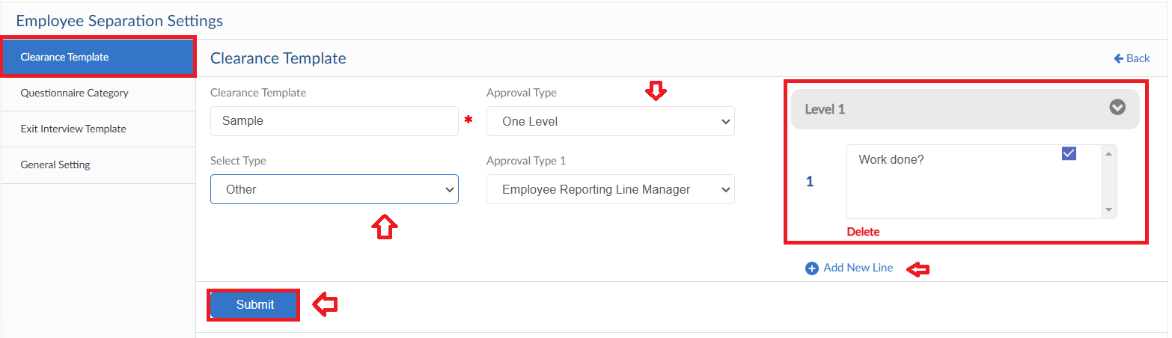

Questionnaire Category
- In this Tab questionnaire category can be added
- Click on Add New Category button, a pop up will be visible
- Enter the category title then click on save button
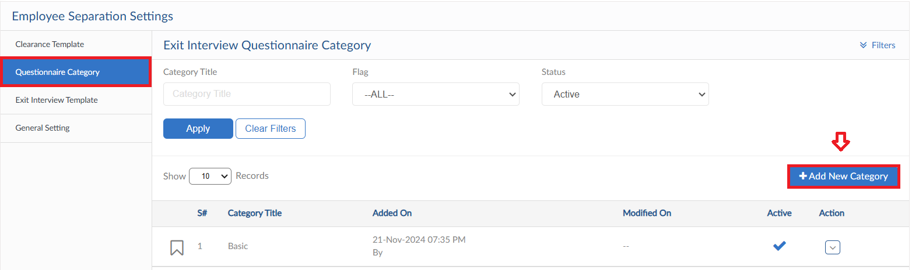
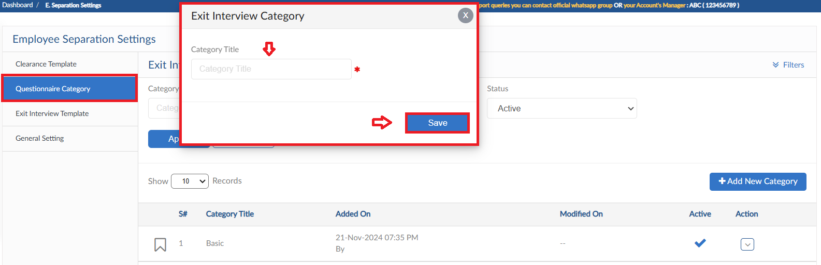

Exit Interview Template
- Moving to the next Tab Exit Interview Template in General settings
- Click on Add Exit Interview Template to create templates
- Enter exit interview details and then click on submit button to save the template and then just select the template from dropdown in Employee Exit
